***Please, provide ALL measurements from this chart*

How to get Measurements
Full name:
(These measurements can be taking in inches
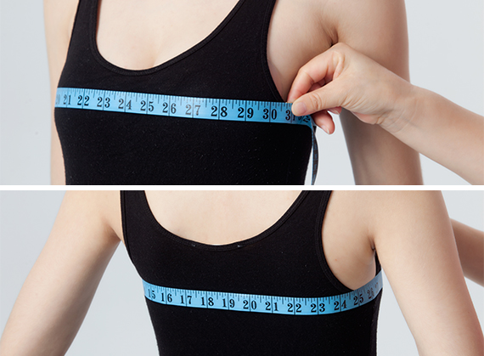 | Full Bust:  (It’s measured around the bust at the fullest point)
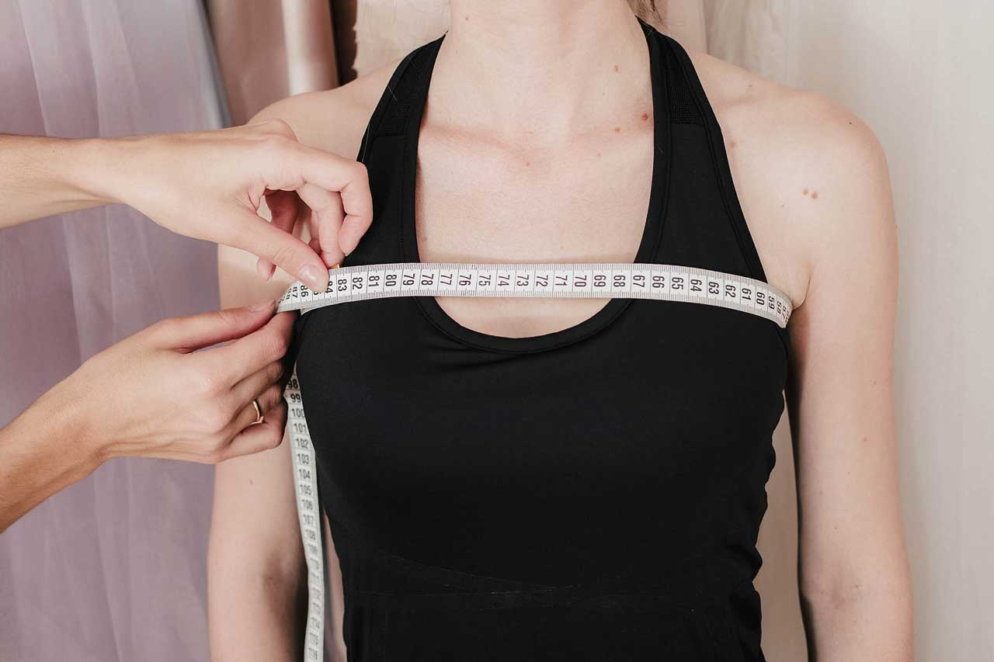 | Upper bust:  (Measure tape must be placed across the shoulder blades, so the upper edge of tape goes right under the back armpit angles and forward just above the breasts.)
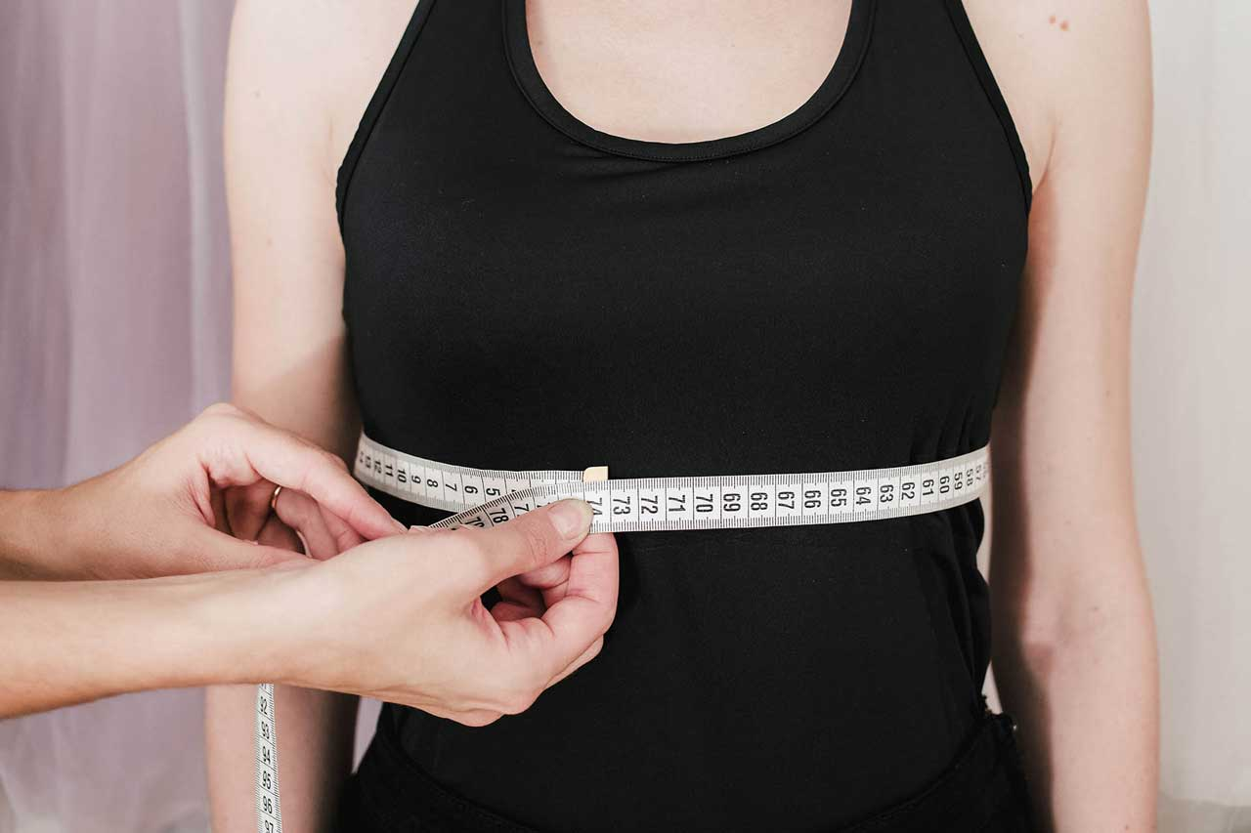 | Under bust:  (It’s measured right under the bust (it’s the line where your bra-tape usually is, around the rib cage.)
 | Nipple to Nipple:
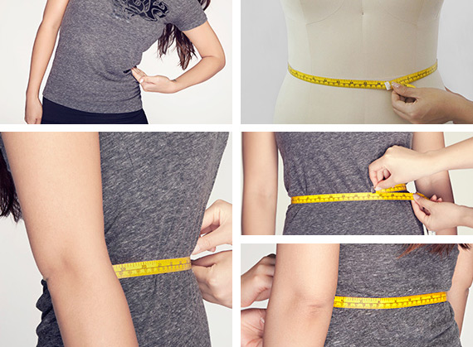 | Waist:  (Bend to one side to find natural indentation in torso. This is your natural waist. Run tape around natural waistline, keeping tape parallel with floor.  - Measure around your natural waist.  - -This is the smallest part of the waist.  - -Usually about 1" above the belly button)
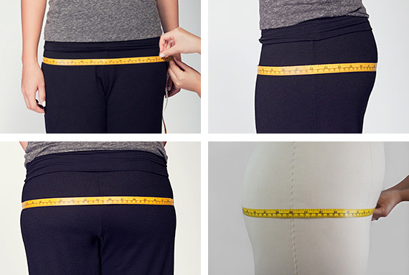 | Hips:  (Wrap tape around the fullest part of your hips, which is usually 7-9" below your natural waistline. Keep tape parallel with floor all the way around.)
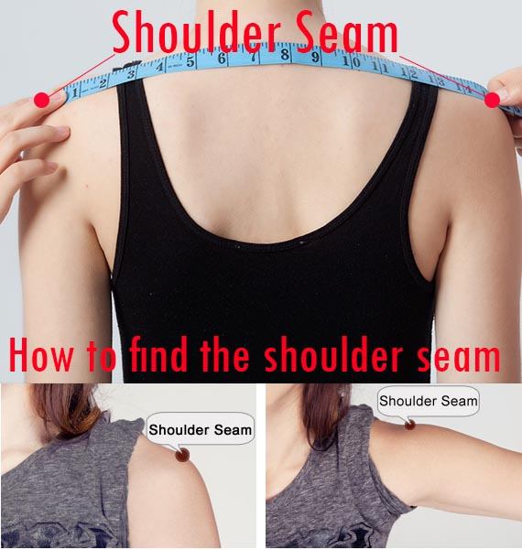 | Shoulder to shoulder:  (From the point of one shoulder seam, measure all the way over to the point of the other along your back.)
Shoulder to bust:_

(It is measured from the shoulder seam line to the nipple)

Shoulder to Waist:

(Measure from Shoulder seam across the bust to the waist)

(Note from Elena: Usually this measurement around 16” if you are 5’4-5’7
for petite size might be 1-2 inches less
for Tall usually adds 1-2” extra)
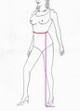 | Waist to floor (without shoes):  (It’s taken vertically by the marks on the wall)
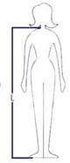 | Length 1:  Shoulder to floor with no shoes:_  (It’s taken vertically by the marks on the wall)
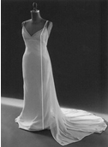 | Length 2:  Shoulder to floor across the bust (without shoes) :_
Stature:
Head to floor with no shoes

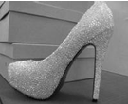 | Shoes heel height:_  (Measure the shoe heel height )
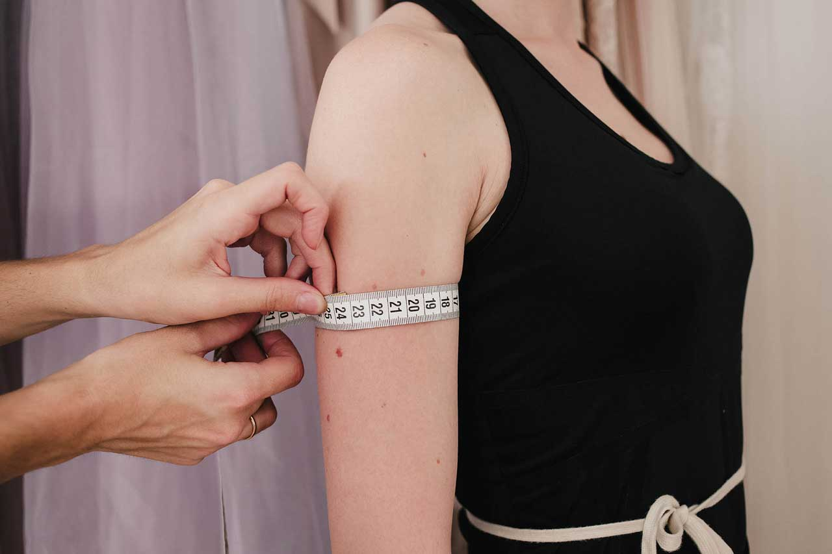 | Bicep:_  (It is measured horizontally, around the fullest part of upper arm. Notice, the arm should be let down and relaxed during the measurements.)
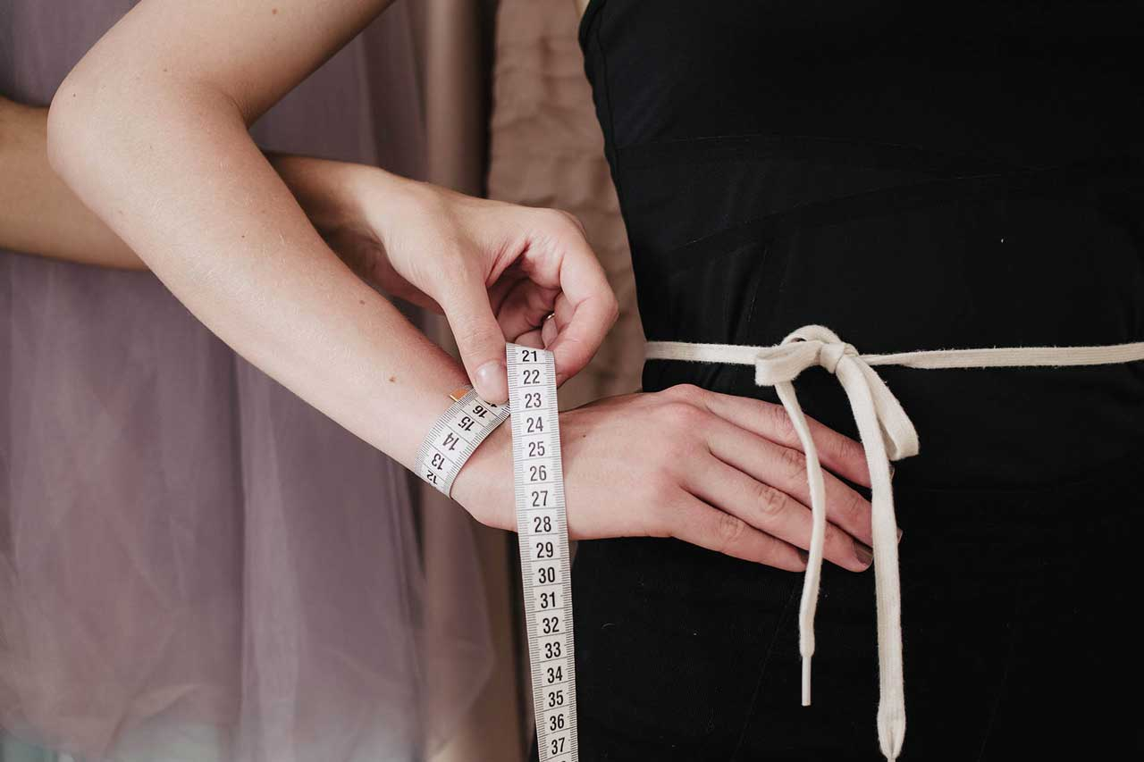 | Elbow ( if needed):  Wrist ( if needed):
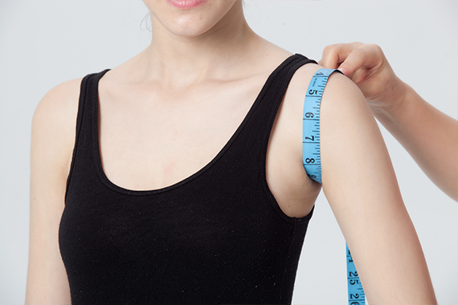 | Arm-hole: ________  (Raise your arm parallel to floor and wrap measure tape around the armpit across the outside edge of shoulder.  Pull your hand down and make sure the tape stays just vertically and only after the last take the measurement.)
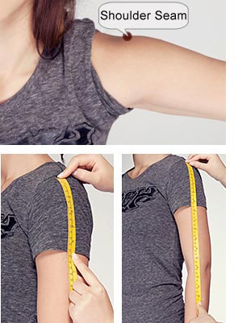 | - Arm Length:_  (Measure from your shoulder seam/point to the wrist.)  - The actual length you want for this dress’ sleeves : __  - Length you want sleeve lining to go to: _________  (if you are making a modest dress)
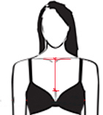 | Neck depth:  (Measure from your collar bone down) :  Back*:
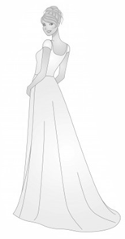 | Would you like a train?  *** if you would like an extra long train between 70-100 inches $50 extra would be added to your dress price

Please DO NOT skip this part and fill out every line.

The color for your dress:__
Back: zipper with buttons
When do you need the dress:_
When is your wedding day:
Would you like a custom veil?______________(An extra charge)
https://myamazingweddingdress.com/product/custom-made-veil/

Contact information:
Name:
Phone_____________/
E-Mail: _________________
Address to ship:
How did you hear about us?____________________________

